10/7/2021



Lab Report # 01

Software Design and Architecture

**Lab Title: Revision of UML concepts**

**Question 1:**

**Draw an appropriate UML diagram for the below given scenario. Also give reasoning of choosing diagram.**

A university consists of multiple faculties. Each faculty is led by a dean, who is an employee of the university. There are many faculties and no of faculties have been known each employee has a job id, name, phone no, and email address. Two categories research and administrative personnel are differentiated according to their duties in the university. Research associative are assigned to at least one institute, each institute has its well-known field of study, which includes project of certain no. of hours, title of project, starting and ending date. Some search associates called lecturers holds courses. All the courses have a unique name, id, no. of hours allocated to them.

**Answer:**

**Why do we need class diagram for given scenario?**

Class diagrams are the blueprints of system or subsystem. We can use class diagrams to model the objects that make up the system, to display the relationships between the objects, and to describe what those objects do and the services that they provide. Class diagrams are useful in many stages of system design.

As class diagram are used to model the static view of the system so, as seen in above scenario it can be better approach to use object-oriented concepts to relate the given information with the help of classes.

In the given scenario there is an employee class generalized with dean class which is child class and inherits some attributes of parent class There are two subclasses named as faculty of engineering and faculty of arts associated with dean class.

Both classes have unique attributes as given in scenario and these are private. Another class which includes some properties and two methods research and administrative personnel are mentioned is associated with one of the child classes of dean. Other classes named as course and project are associated with subclass named as categories with some properties mentioned above.

**Class Diagram:**

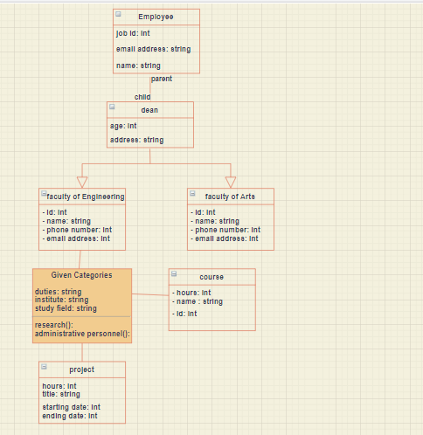

**Question 2:**

**Create a sequence diagram for following scenario of WhatsApp application**

* Creating a group on WhatsApp, sending the first message to the group, and checking status information of message sent.
* Sharing a picture and then a video from your gallery over your WhatsApp status and then checking who viewed your status.
* Creating and sending a new broadcast
* Do a video call to one of your WhatsApp contacts.

**Answer:**

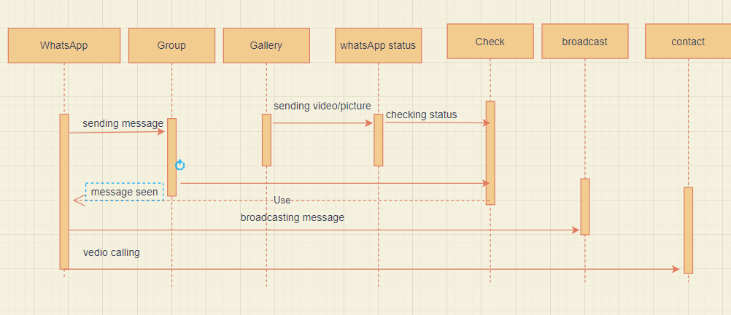

According given scenario, using sequence diagram at first the message is sent to WhatsApp group and then checked whether message has been reached or not.

Any picture or video is sharing from gallery to WhatsApp status and then checking who has seen it. Similarly, a message is broadcasted.

And doing a video call from WhatsApp to one of our contacts saved.